System of Systems Engineering Evolution from Broader Industry Perspectives and the Role of System of Systems Engineering Conference: INCOSE and IEEE Collaborations

By
Garry Roedler ¹ Paul Hershey² and Mo Jamshidi ³
- Retired Fellow, Lockheed Martin Company
- Fellow, Raytheon Technologies Corporation
- Lutcher Brown Endowed Chair, The University of Texas at San Antonio

Abstract This article attempts to provide a brief history of collaborations between The International Council on Systems Engineering (INCOSE) and the Institute of Electrical and Electronic Engineers (IEEE) in a broad-based a 21st Century approach to security challenges of defending America. A joint IEEE-INCOSE forum was born in 2006, which is now known at the SoSE Conference. The SoSE conference has provided an outstanding venue in which to share and vet new SoSE ideas and collaborate with colleagues from defense and aerospace industries systems and more.

- SoSE Evolution
The International Council on Systems Engineering (INCOSE) was founded in 1990 to provide a focus specifically on Systems Engineering (SE). Although System of Systems (SoS) did exist at that point in time, the term was not as widely used and the concepts for System of Systems Engineering (SoSE) were just evolving. With the expansion of the internet and growth of interconnected systems in the early 2000’s, there was a realization across much of the industry that we needed to proactively consider the technical and managerial impacts across the life cycles of interacting systems. During this time, the topic of SoS started to appear in conferences, including the INCOSE International Symposium. As the focus on SoS continued to grow, working groups or committees formed in INCOSE, the Institute for Electrical and Electronic Engineers (IEEE), and the National Defense Industrial Association’s (NDIA) SE Division. Additionally, there was a realization that the community would benefit from a conference dedicated to SoSE. The SoSE conference is now sponsored by both INCOSE and IEEE.
The SoSE stakeholder groups mentioned above have had significant impact in driving the awareness and consistent technical perspectives of SoSE in a very short time. The following outlines some of the key accomplishments in over the past two decades. (Note that this is not intended to be an exhaustive list.)
- One of the first significant publications on SoS that has stood the test of time is "Architecting Principles for Systems-of-Systems" by Mark Maier in 1998.
- US Department of Defense Systems Engineering Guide on System of Systems (2008) was the first major guide for SoSE. It is still a valid and useful resource for both the defense and non-defense sectors.
- NDIA SED SoS Committee was formed in 2009. They have provided an important industry focus for the defense sector for the adoption of the DoD Guidance. They have also provided a forum for government and industry to collaborate, as well as also collaborating with other industry associations.
- INCOSE SoS Working Group (WG) was formed in 2012 and has created the following products that are available on the INCOSE Website:
  - SoS pain points survey report
  - System of Systems Primer
  - System of Systems Standards (an overview of New Standards for System of Systems Engineering)
  - SoS Webinar series
  - Other valuable activities are performed by the SoS WG
- International cooperative research effort - TTCP TECHNICAL REPORT TR – JSA/TP4 -1- 2014 Recommended Practices: System of Systems Considerations in the Engineering of Systems,August 2014
- ISO/IEC JTC1/SC7 conducted a study group during 2015-2016 that was jointly chaired by SC7 and INCOSE. The objective of the study was “To report on the potential for standardization in SC7 in the area of Systems of Systems Engineering (SoSE).” The study concluded that the area of SoSE had matured to the point that standardization for SoSE was appropriate and there was a recommendation for three standards.
- Three international standards were developed during 2016-2019 for SoSE. They formed a new foundation for viewing the concepts and requirements for systems participating in a SoS and for the application of SE for the SoS. The three standards are:
  - ISO/IEC/IEEE 21839, System of Systems Considerations in Life Cycle Stages of a System
  - ISO/IEC/IEEE 21840, Guidelines for the use of ISO/IEC/IEEE 15288 in the context of system of systems
  - ISO/IEC/IEEE 21841, Taxonomy of systems of systems
- Several key books have also been published by members of both the academic and industry sectors. These have served to bring the awareness and understanding of SoSE further.
During the course of 2018 to present, SoSE has been viewed as an essential part of SE in general. Today there are few relevant systems that are not part of a SoS. Figure 1 shows the growth of interconnectedness of systems and rise of connecting SoS’s across enterprises.
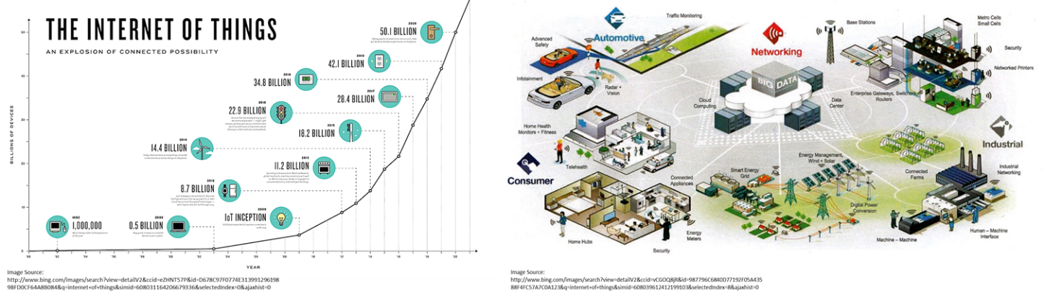

Figure 1. The growth of interconnectedness of systems and rise of connecting SoS’s across enterprises

With this growth have come many new challenges in the development of the constituent systems that participant in the SoS. Figure 2 shows the challenges facing systems engineering community in a presentations by the first author.
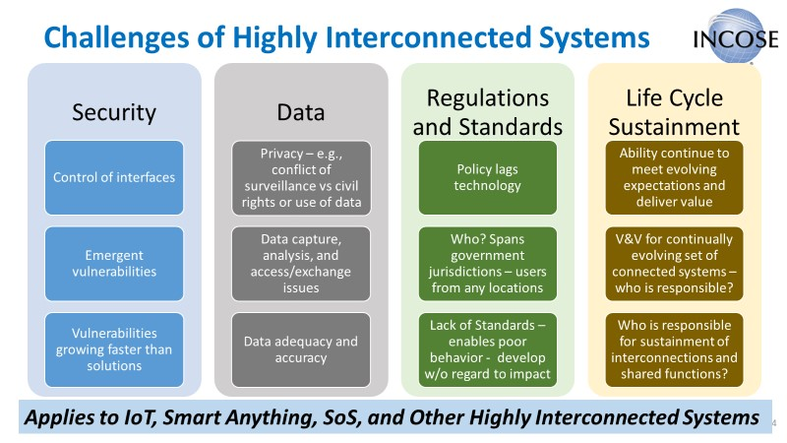
Figure 2. IoT, Smart Anything, SoS, and other interconnected systems
So the SoS challenges require additional considerations and looking at the development of new solutions from a somewhat different perspective. At the top level, these can be summarized as follows:
- SoS Governance / Authority
  - Who is in charge? Who makes decisions? Who has financial responsibility?
- Independent versus holistic perspectives
  - Constituent system versus SoS (holistic) trades and decisions
- Impacts from emergence or from other systems
- Security across the SoS, including new threats or vulnerabilities
- SoS requirements
  - Constituent system requirements versus SoS needs – may be a mismatch
  - Impact of new SoS requirements on the constituent system as a user of the SoS
- Verification and validation of SoS capabilities – who and how?
- Standards are still evolving
In January of 2018, INCOSE started an initiative to look at the Future of Systems Engineering (FuSE). It was established due to the need to address the evolving challenges and impacts from interconnectedness, dynamic changes and nondeterminism in systems and their environments, new technologies (such as artificial intelligence and autonomy), and digital transformation. Naturally, a focus on SoSE has become a part of this effort.
As we move forward, it will be important to continue to look at SoSE in context with the other changes and challenges in SE. The working groups and conferences that are dedicated to SoSE are essential for the industry to be able to keep informed and leverage the lessons learned, as well as influence the future directions to meet their needs.
- System of Systems Engineering Evolution Based on Industry Needs
As new commercial and military systems evolve, engineers face significant challenges that require solutions beyond traditional systems engineering. System of Systems Engineering (SoSE) has thus evolved to account for SoS that are operationally independent, managerially independent, physically decoupled, and geographically distributed. SoSE addresses issues associated with evolutionary development such as complexity, phasing, and emergent behavior. By following SoSE design principles, industry is able to develop products that satisfy investors who require that their substantial investments last for many years. In particular, industry demands that producers deliver SoS applications that will reduce procurement cycle, streamline system engineering activities, produce longer life and more sustainable systems, and improve product cost-effectiveness. [1]
The issue of complexity is a key industry driver in the evolution of SoSE beyond that of traditional systems engineering. A complex system is one whose structure and behavior is not deducible, nor may it be inferred, from the structure and behavior of its component parts. SoSE address complexity beyond traditional systems engineering by approaching a system from an enterprise perspective, recognizing that enterprises are unique and evolve to increase their own complexity [2]. Another issue where industry is now relying on SoSE for solutions is that of emergent behavior in complex systems. Emergent behavior develops from the interactions among constituent systems and cannot be deduced from the behaviors of the constituent systems themselves, considered individually or in subgroups.
The military industry has moved towards SoSE-based solutions to tackle the challenges of advanced threats from high-tech adversaries that characterize the above complex and emergent behaviors. To counter such threats, rigorous SoSE approaches are required to coordinate combat across multiple battlefield domains, e.g., land, sea, air, space, and cyberspace. Present solutions based on traditional system engineering are largely single-system-based and lack the analysis and mission situational awareness to support multi-domain mission operations. An example of the applying SoSE to address military needs is that systems security and safety-critical systems for real-time multi-domain military missions. SoSE methodology spans the systems life cycle for such systems that include medical systems, energy and power systems, transportation systems, chemical and hazardous material systems, industrial process systems, and air-, land-, and sea-based single domain and multi-domain military systems. [3]

- IEEE’s Initiative in SoSE
In 2003, the third author was assigned to chair the annual conference of the IEEE Systems Man and cybernetics (SMC) in October 2005. Destination was the Big Island of Hawaii. The third author, who had been exposed to SoS at NASA on assignment, chose the theme of IEEE SMC 2005 as “System of Systems. The event in 2005 attracted several participants from the aerospace industry, likes of Boeing, Raytheon, Lockheed Martin, etc. Encouraged by the active participation and apparent needs of the aerospace and defense industries, a decision was made to launch a dedicated IEEE Conference on SoSE in May 2006 in Los Angeles. Both SMC and IEEE Systems Council (SC) agreed to financially sponsor it and the third author was the chaired this new meeting. In Los Angeles, over 60 participants attended the first conference and once again, a significant number of industry professionals came. The next three meetings took place in San Antonio (2007), Monterey Bay (2008) and Albuquerque (2009), respectively. Unfortunately, due to the national recession, the last 2 events lost finances and both IEEE organizations withdrew their financial sponsorships. At the time, it was decided to continue the conference without financial support of the IEEE and financial responsibility was bestowed on Universities of key players in this meeting. University of Texas and Loughbrough University (UK) took the responsibilities and took the meeting to UK. Professor Michael Henshaw played a key role in opening Europe to SoSE in 2010. This time European industry also joined the American ones and a very rich technical conference took place. As, they say, “the rest is history”. SoSE went to Albuquerque (2011), Genova, Italy (2012), Maui (2013), Adelaide, Australia (2014), San Antonio (2015), Kongsberg, Norway (2016), Big Island of Hawaii (2017), Paris (2018), Anchorage, Alaska (2019), Budapest (2020) and in 2021 it will be in Stockholm, Sweden. As a result of SoSE’s success, the first author edited two volumes on SoSE [4,5] and one book series on SoSE by CRC Publishers.

Starting with the SoSE 2012 in Italy, INCOSE decided to technically sponsor the conference with active support of the first author. IEEE SMC also decided to only technically sponsor the event and hence the conference evolved and matured as a unique co-sponsorship of IEEE and INCOSE. SoSE series of meetings have created a national and international platform for annual gathering of systems engineers, SoSE researchers, and industry practitioners as an outstanding venue in which to share and vet new SoSE ideas and collaborate with colleagues from these industry systems and more.

- Conclusion
This paper presented a brief history of system of systems engineering and the beneficial collaborations of INCOSE and IEEE to set an annual venue of solving the 21st Century challenges of the America’ national security through an SoSE approach.

References
[1] “Defense Acquisition Guidebook (DAG),” Jan. 2012, [Online], Available: https://dag.dau.mil/Pages/Default.aspx, US Dept. of Defense. 2. Systems Engineering Guide for Systems of Systems, Version 1.0, ser. OUSD (A&T) SSE. Ofﬁce of the Deputy Undersecretary of Defense Acquisition and Technology, Systems and Software Engineering, Aug. 2008.

[2] Flavio Oquendo, “Architecturally Describing the Emergent Behavior of Software-intensive System-of-Systems with SoSADL,” IRISA – UMR CNRS / Univ. Bretagne Sud, France flavio.oquendo@irisa.fr, 2017 12th System of Systems Engineering Conference (SoSE), June 18-21, 2017 Waikoloa Hawaii, USA].
[3] Norman D.O., Kuras M.L. (2006) Engineering Complex Systems. In: Braha D., Minai A., Bar-Yam Y. (eds) Complex Engineered Systems. Understanding Complex Systems. Springer, Berlin, Heidelberg© Springer 2006, pp 206-245.]
[4] M. JAMSHIDI (ed.), Systems of Systems Engineering – Principles and Applications, CRC – Taylor & Francis Publishers, London, UK, 2008. Mandarin version, China Machine Press, Beijing, China, 2013.

[5] M. JAMSHIDI (ed.), System of Systems Engineering – Innovations for the 21st Century, John Wiley & Sons, Publishers, New York, NY, 2009.

About the Authors:
Garry Roedler, ESEP is Retired Lockheed Martin Senior Fellow, INCOSE Past President, Fellow, and Founder Award Recipient, IEEE-CS Golden Core and IEEE-SA Lifetime Achievement Award Recipient, and NDIA Ferguson Systems Engineering Excellence Award Recipient

Paul C. Hershey, Ph.D. is a Principal Engineering Fellow at Raytheon Technologies Corporation.

Mo Jamshidi, Ph.D., F-IEEE, F-ASME, F-AAAS, F- NYAS, F-TWAS and AF-AIAA is a n Endowed Chaired Professor at the University of Texas at San Antonio and was formerly assigned to advise NASA, USAF, DOE in consulting, special Government Employee, or IPA Professor and currently serving on the US Army Science Board.

