System of Systems Engineering
Collaborators Information Exchange (SoSECIE)

March 15th, 2022
11:00 a.m. to Noon Eastern Time

Autonomous Cyber-Physical Systems:
System engineering and development

Presenter: Mara Nikolaidou

IoT paradigm has revolutionized our daily routine life, connecting a plethora of smart devices, sensors, frameworks, intelligent systems and humans, in order to provide innovative solutions to everyday problems. With the advent of emerging technologies, Cyber-Physical Systems (CPSs) shown great potential in latest years in various application areas, such as healthcare, urban environments, transportation, environment monitoring, home automation or the agricultural domain. As they comprise of parts interacting with the physical environment and others having computing and communication capabilities, they constitute systems-of-systems formed by autonomous components. Their properties, design and development become increasingly complex. The presentation targets at presenting open issues in CPS engineering in a holistic fashion and introduces our ongoing projects in CPS engineering into three different levels: 1) Smart aggregators to manage sensor and actuators and collaborate within each other in an autonomous fashion. A self-control management middleware has been developed for this purpose. 2) Coordination of services running in such environment with no central control. The notion of ephemeral services will be discussed and our efforts towards developing a multi-level micro-service event-based service composition framework will be explored. 3) The integration of humans into CPS and their wiliness to become parts of them. A multi-view design approach focusing on human concerns as system design requirements and the concept of human critically has been developed targeting medical CPS. These efforts are presented in the context of specific case studies from prominent CPS domains, targeting smart building management, smart farm management and remote patient monitoring.

Biography

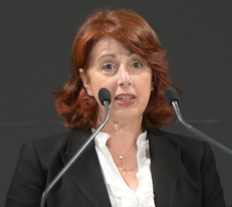
Mara Nikolaidou is a Professor in the Department of Informatics and Telematics at Harokopio University of Athens. She also currently serves as the Rector of the University (since 2016). Her research interests include SoS engineering, system modeling and simulation, service-oriented architectures and BPM. Over the last years she actively participated in numerous research projects funded by national, European and international agencies on system engineering, service-oriented architectures, digital libraries and e-government. She is currently involved in research projects focusing on SoS engineering, the Internet of Things, Cyber-physical Systems and Smart Cities. She has published more than 200 papers in international journals and conferences and actively participates in the organization of international conferences in the area of software and systems engineering. She is a member of IEEE SMC society and Systems Council.

