System of Systems Engineering
Collaborators Information Exchange (SoSECIE)

September 7, 2021
11:00 a.m. to Noon Eastern Time

System of Systems Meta-Architecture Approach to Improve Legacy Metrorails for Enhanced Customer Experience

Presenter: Dr. Cihan Dagli

Abstract
As technology surges forward, some Metrorail networks have become outdated customer-facing systems in need of updates. To help enhance overall traveler experience, the following Key Performance Attributes (KPAs) need improvement: predictability, accessibility, reliability, affordability, and scalability. By maximizing these KPAs, a legacy Metrorail system could see increased ridership, thus potentially increasing overall revenue generated by the system. In order to assess the overall fitness measure of the System of Systems (SoS), a Fuzzy Inference System (FIS) developed along with a set of feasible, participating systems and KPA-defining equations. A simple Genetic Algorithm (GA) was used to find the optimized meta-architecture. Using the methodologies described in this presentation, an optimized SoS meta-architecture for improving a legacy Metrorail system was generated and assessed.

Keywords— Metrorail, Meta-Architecture Generation, System of Systems, Fuzzy Inference System

Biography
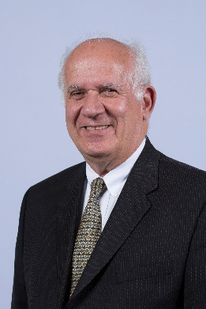
Dr. Dagli is a Professor of Systems Engineering and Engineering Management, and is also a Professor of Computer and Electrical Engineering. He is the founder of Missouri S&T’s Systems Engineering Graduate Program and the director of the Smart Engineering Systems Lab (SESL). He received B.S. and M.S. degrees in Industrial Engineering from the Middle East Technical University and a Ph.D. in Applied Operations Research in Large Scale Systems Design and Operation from the University of Birmingham, United Kingdom, where from 1976 to 1979 he was a British Council Fellow. Dr. Dagli is a fellow of the International Council of Systems Engineering (INCOSE) 2008 and Institute of Industrial and Systems Engineers (IISE) 2009 and International Foundation of Production Research 2019. His research interests are in systems engineering and systems architecting, cyber physical systems, deep learning, machine learning and computational intelligence.

Maxwell Polley is a systems engineer and recent graduate of the University of Missouri of Science and Technology. He received his B.S. in aerospace engineering from Saint Louis University and a M.S. in Systems Engineering from Missouri S&T. Committed to lifelong learning, his research interests include in systems engineering, model-based systems engineering, and systems architecting.

