System of Systems Engineering
Collaborators Information Exchange (SoSECIE)

December 1, 2020
11:00 a.m. to Noon Eastern Time

Case Study: Achieving System Integration through Interoperability in a large System of Systems (SoS)

Presenter: Oliver Hoehne

Abstract

This webinar provides a case study on system of systems engineering (SoSE) being performed in a multi-billion-dollar program – the California High-Speed Rail System – viewed from the systems integration perspective. The webinar discusses why the subject program of projects (PoP) can be viewed as a system of systems (SoS), identifies the SoSE challenges faced, describes the SoSE activities performed, and summarizes the achieved outcomes and conclusions as of today. Specific SoSE challenges discussed include SoS authority, leadership, architecting, collaboration, integration, and emergence. The webinar reviews how decision-making in independently operated and managed constituent systems (projects) resulted in unanticipated SoS emergent behavior, which is one of the key challenges in the engineering of SoS. The webinar further discusses the performed SoSE activities, including an international best practice review, the tailoring of SoSE to the specific SoSE challenges, and provides examples where SoSE principles are being applied to perform successful SoS integration.

Biography

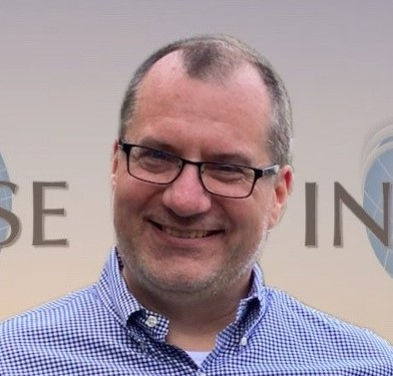
Oliver Hoehne is a Technical Fellow, Systems Engineering, a Project Manager, and the U.S. Global Technical Excellence Sector and Practice Lead on Systems Engineering, Communications and Control Systems for WSP, a company with 30,000+ employees, in 500 offices across 39 countries. Mr. Hoehne is a Project Management (PMP) and Systems Engineering Professional (CSEP) with over 20 years of extensive international and domestic experience in Software and Systems Engineering across industries, and has worked in leading Systems Engineering, Integration & Testing (SEIT) roles on several multi-billion-dollar programs.

