System of Systems Engineering
Collaborators Information Exchange (SoSECIE)

September 22, 2020
11:00 a.m. to Noon Eastern Time

System of Systems (SoS) Meta-Architecture Selection for Infrastructure Inspection System Using Aerial Drones
Presenters: Dr. Cihan Dagli and Muhammad Monjurul Karim

Abstract

Infrastructure inspection using unmanned aerial drones has a great potential to support complex inspection tasks especially where inspection task can be dangerous, dull or dirty. The increased number of systems in this type of inspection process makes it a very complex systems-of-systems (SoS) which is hard to assess. As a result, it becomes very difficult to satisfy all stakeholder needs and requirements. Therefore, an assessment system is required that can efficiently assess the meta-architecture of drone based inspection system. This paper presents a method to generate and evaluate systems of systems (SoS) architecture model for aerial inspection with drones. Where, a meta-architecture containing system component and a system to system interface is presented. To map the desired SoS attributes from stakeholders, different characteristics of the architecture capabilities are evaluated using some linguistic terms called key performance attributes (KPA). KPAs are combined in a Fuzzy Inference System (FIS) to evaluate an overall fitness value that is optimized using a Genetic Algorithm (GA) for the SoS within the meta-architecture. The integrated evaluation method presented in this paper utilizes the SoS explorer to evaluate the SoS meta-architecture using synthetic parameter values.

Biographies

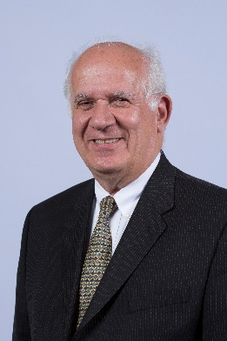
Dr. Dagli is a Professor of Systems Engineering and Engineering Management and also a Professor Computer and Electrical Engineering. He is the founder of Missouri S&T’s Systems Engineering Graduate Program and the director of the Smart Engineering Systems Lab (SESL). He received B.S. and M.S. degrees in Industrial Engineering from the Middle East Technical University and a Ph.D. Applied Operations Research in Large Scale Systems Design and Operation from the University of Birmingham, United Kingdom, where from 1976 to 1979 he was a British Council Fellow. Dr. Dagli is a fellow of International Council of Systems Engineering INCOSE 2008 and Institute of Industrial and Systems Engineers IISE 2009 and International Foundation of Production Research 2019. His research interests are in systems engineering and systems architecting, cyber physical systems, deep learning, machine learning and computational intelligence.

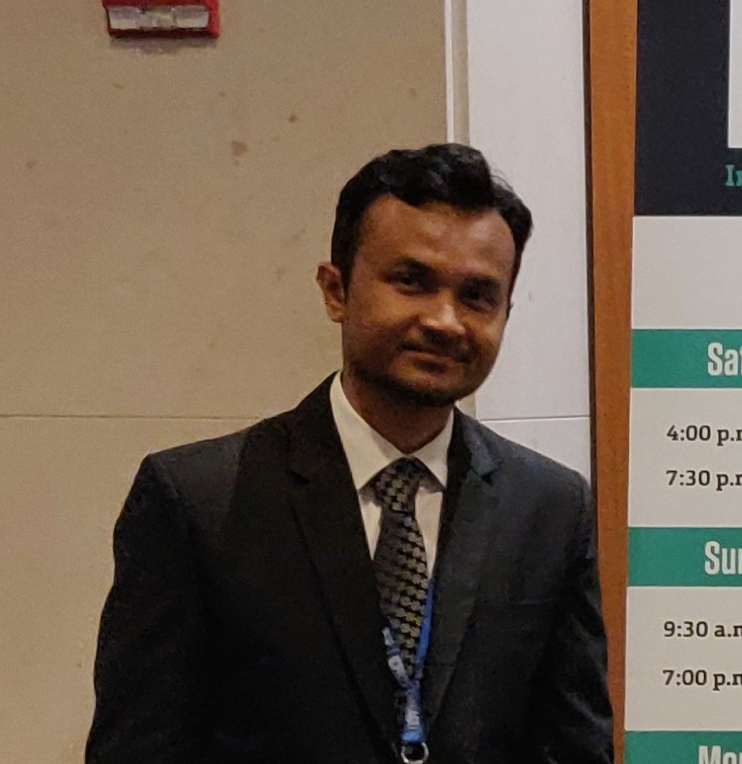
Muhammad Monjurul Karim obtained his M.S. degree in Systems Engineering from Missouri University of Science and Technology. Prior to that he worked in several manufacturing companies in Bangladesh. Previously he obtained his B.S. degree in Industrial and Production Engineering from Bangladesh University of Engineering and Technology, Bangladesh, in 2014. His areas of interest include development of cyber physical systems using computer vision, deep learning modeling, Infrastructure systems engineering, etc. Monjurul started his Ph.D. studies in Civil Engineering at Stony Brook University in Fall 2020.

