System of Systems Engineering
Collaborators Information Exchange (SoSECIE)

September 8, 2020
11:00 a.m. to Noon Eastern Time

A System of Systems Approach to Optimize a Real-time Risk Situational Awareness System
Presenters: Dr. Cihan Dagli and Yu Li

Abstract

In 2017, about 37,151 fatalities resulted from motor vehicle traffic crashes. Crashes cost the U.S. over $800 billion annually in lives lost or injured, lost productivity, and property damage. Many interventions have been adopted to reduce fatalities and serious injuries. A real-time crash intervention can estimate the chance of crash occurrence and analyze risk factors of live video streams captured by the onboard camera of a vehicle, so as to notify the driver to take the appropriate response. This applied research is aimed to improve the prediction to achieve an optimal system by integrating existing risk factors, the algorithms to identify and analyze risk factors result in visualization, etc. Existing systems are integrated into a System of Systems (SoS), the overall objective of which is to maximize the Key Performance Attributes (KPA): Performance of the SoS predicted Time, Performance of the SoS predicted Decision, Affordability, Scalability and Adaptability. The meta-architecture is structured as a chromosome assessed and selected with the non-gradient optimization approach based on the simple genetic algorithm integrated with a Fuzzy Inference System.

Biographies

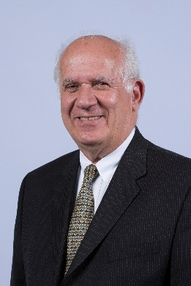
Dr. Dagli is a Professor of Systems Engineering and Engineering Management and also a Professor Computer and Electrical Engineering. He is the founder of Missouri S&T’s Systems Engineering Graduate Program and the director of the Smart Engineering Systems Lab (SESL). He received B.S. and M.S. degrees in Industrial Engineering from the Middle East Technical University and a Ph.D. Applied Operations Research in Large Scale Systems Design and Operation from the University of Birmingham, United Kingdom, where from 1976 to 1979 he was a British Council Fellow. Dr. Dagli is a fellow of International Council of Systems Engineering INCOSE 2008 and Institute of Industrial and Systems Engineers IISE 2009 and International Foundation of Production Research 2019. His research interests are in systems engineering and systems architecting, cyber physical systems, deep learning, machine learning and computational intelligence.

Yu Li obtained her M.S. degree in Systems Engineering and Model Based Systems Engineering graduate certificate from Missouri University of Science and Technology. She worked as a Quantity Surveyor in Rider Levett Bucknall from 2012 to 2017 in Beijing, China. She obtained her B.S. degree in Engineering Management from Yichun University, China, in 2012. Her areas of interest include new transmission and maintenance technologies, crash data analysis, transportation safety, etc. Yu Li started her Ph.D. studies in Civil Engineering at Stony Brook University in Fall 2020.

